Image | File name | Caption
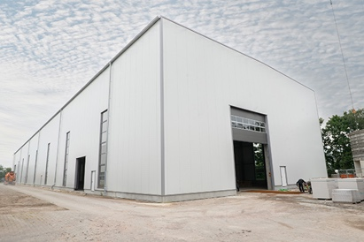 | RichardBrink_CargoWunstorf_01 | BRUGG Rohrsysteme GmbH has added a new hall to its manufacturing facilities in Wunstorf. The project was overseen by RRR Stahl- und Gewerbebau GmbH from Lage.  Photo: Richard Brink GmbH & Co. KG
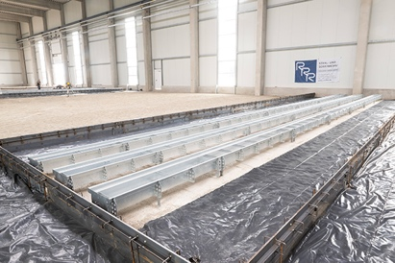 | RichardBrink_CargoWunstorf_02 | Sensitive lines including PVC pipes for water and steel pipes for chemicals were to be laid in the foundation. To ensure constant accessibility for repair and maintenance work, RRR opted for the Cargo supply channel from Richard Brink GmbH & Co. KG.  Photo: Richard Brink GmbH & Co. KG
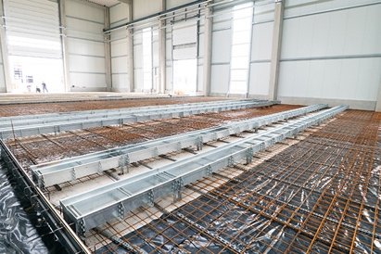 | RichardBrink_CargoWunstorf_03 | With their two-part construction, the channels feature an integrated expansion joint thanks to the separation slot along the longitudinal centre axis. This enables it to be seamlessly cast into the surrounding concrete.  Photo: Richard Brink GmbH & Co. KG
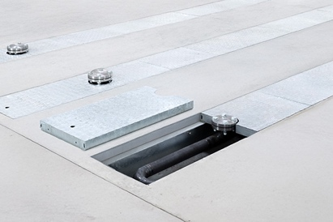 | RichardBrink_CargoWunstorf_04 | The metal products manufacturer from Eastern Westphalia also supplies expertly processed accessories such as the company’s own gratings and end pieces. This means that the customer is always supplied with a ready-to-install, full package on the construction site.  Photo: Richard Brink GmbH & Co. KG
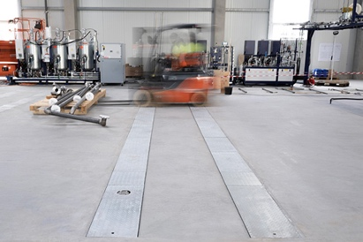 | RichardBrink_CargoWunstorf_05 | A key benefit for the use of the supply channel from Richard Brink in industrial halls is its ability to withstands heavy loads of up to 10 tonnes.  Photo: Richard Brink GmbH & Co. KG
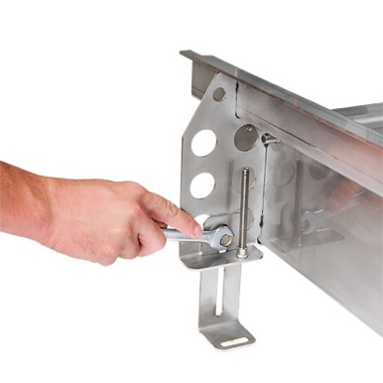 | RichardBrink_CargoWunstorf_06 | The channel also has an optional height-adjustable capability thanks to an elongated hole within the feet. The position can be fine-tuned using an additional threaded rod.  Photo: Richard Brink GmbH & Co. KG
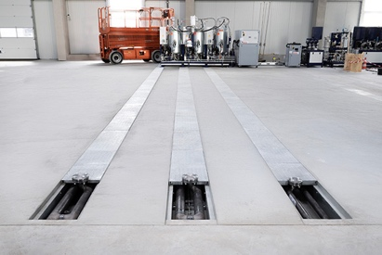 | RichardBrink_CargoWunstorf_07 | Richard Brink also offers all dimensions of the Cargo made from 3mm-thick stainless steel or hot-dip galvanised steel either as a standard or made-to-measure version.  Photo: Richard Brink GmbH & Co. KG

