Image | File name | Caption
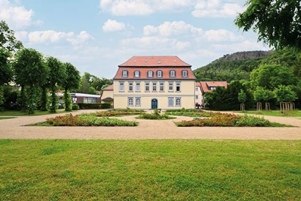 | RichardBrink_StadtparkOker_01 | The area in front of Cramer von Clausbruch Villa in the eastern part of Goslar’s Oker municipal park was redesigned in a historical parterre style as part of the park’s renovation.  Photo: Richard Brink GmbH & Co. KG
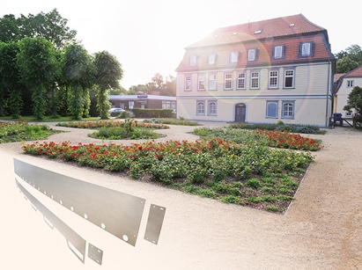 | RichardBrink_StadtparkOker_02 | This involved, for example, making the paths narrower across the almost 500-square-metre space, which is now framed by mirrored linden groves. New flower beds featuring steel strips made by Richard Brink were installed across a section of the garden measuring approx. 250 square metres.  Photo: Richard Brink GmbH & Co. KG
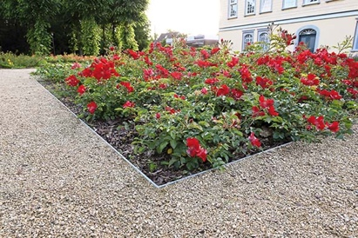 | RichardBrink_StadtparkOker_03 | The metal products manufacturer from Eastern Westphalia supplied around 200m of both straight and custom pre-curved steel-strip edgings and the respective connectors made of hot-dip galvanised steel. The edgings are 150mm high and 6mm thick.  Photo: Richard Brink GmbH & Co. KG
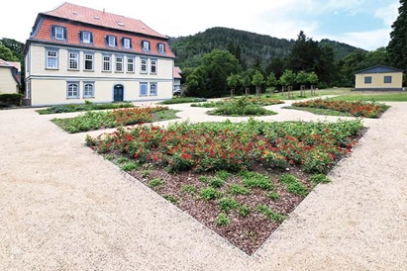 | RichardBrink_StadtparkOker_04 | The enhanced appearance aims to reinforce the park’s recreational value while creating an organic ensemble together with the grand façade of the former manor house.  Photo: Richard Brink GmbH & Co. KG
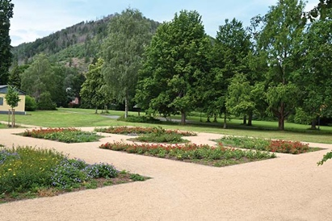 | RichardBrink_StadtparkOker_05 | What’s more, the typical parterre planting and the broad view from the garden has opened up a line of sight between the park and the surrounding Harz panorama.  Photo: Richard Brink GmbH & Co. KG

