Image | File name | Caption
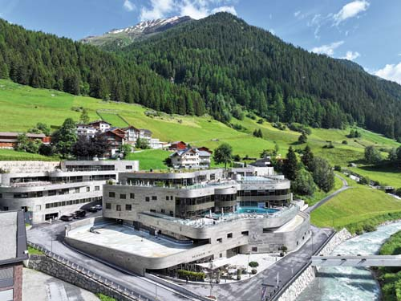 | RichardBrink_Silvretta_01 | The Silvretta Therme Ischgl – a wellness oasis with ambitious standards in terms of sustainability and energy efficiency – was built between 2019 and 2022 against an impressive mountain backdrop.  Photo: Richard Brink GmbH & Co. KG
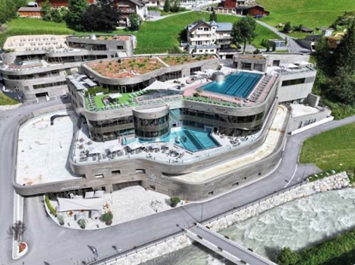 | RichardBrink_Silvretta_02 | The thermal spa complex with its varied amenities stretches across multiple levels. Water in its various physical states serves as the connecting element for the overall concept.  Photo: Richard Brink GmbH & Co. KG
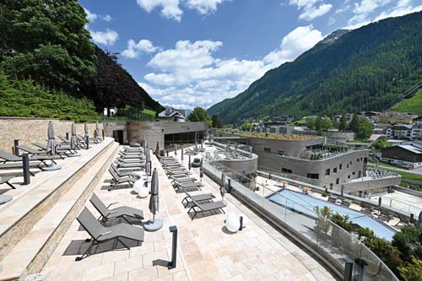 | RichardBrink_Silvretta_03 | The large external terraces with their open-air pools and relaxation areas offer the guests a unique view of the Alpine landscape.  Photo: Richard Brink GmbH & Co. KG
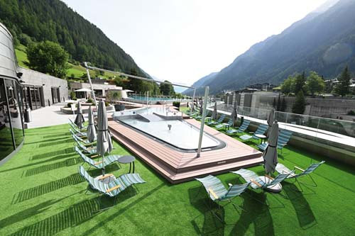 | RichardBrink_Silvretta_04 | Because of their location and size, the external areas are exposed to changing weather conditions all year round – from sun through rain right up to snowfall.  Photo: Richard Brink GmbH & Co. KG
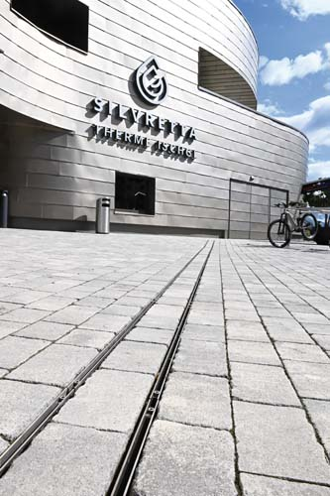 | RichardBrink_Silvretta_05 | Efficient rainwater management on the site was essential. Gemini Magna double-slit channels from Richard Brink in the entrance are of the newbuild are perfectly suited to this task.  Photo: Richard Brink GmbH & Co. KG
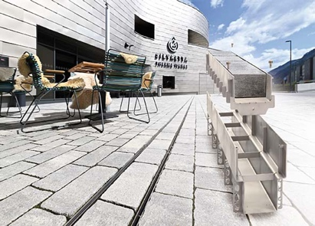 | RichardBrink_Silvretta_06 | A total of 22 metres of the channels for heavy-duty use were used. Each channel is comprised of a stone inlay and the channel body – for a minimalist look with maximum load-bearing capacity.  Photo: Richard Brink GmbH & Co. KG
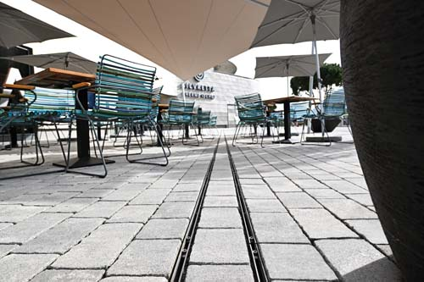 | RichardBrink_Silvretta_07 | The stone inlays are a perfect match to the paving material used, creating a harmonious and consistent overall picture.  Photo: Richard Brink GmbH & Co. KG
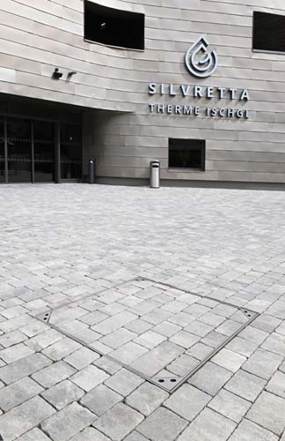 | RichardBrink_Silvretta_08 | Manholes by the entrance were covered with Solid manhole covers from the metal goods manufacturer.  Photo: Richard Brink GmbH & Co. KG
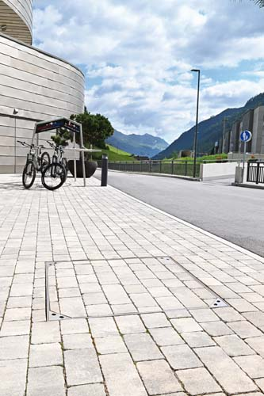 | RichardBrink_Silvretta_09 | The variant of the manhole covers supplied is capable of withstanding trucks. The lid consists of a paved inlay into which the slab material can be inserted.  Photo: Richard Brink GmbH & Co. KG
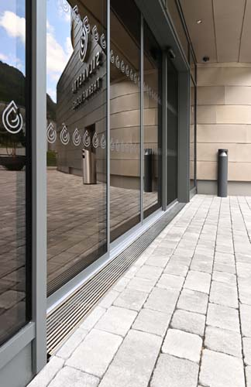 | RichardBrink_Silvretta_10 | Hydra drain channels in door areas and thoroughfares ensure that rainwater is collected at the threshold for controlled drainage.  Photo: Richard Brink GmbH & Co. KG
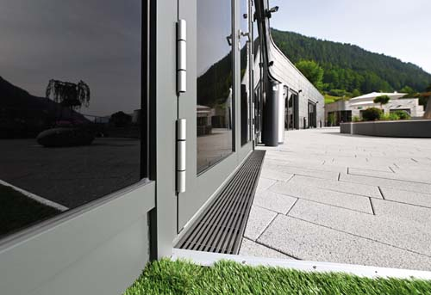 | RichardBrink_Silvretta_11 | The adjustable drainage channels enable contractors to adjust them to the local conditions quickly and easily.  Photo: Richard Brink GmbH & Co. KG
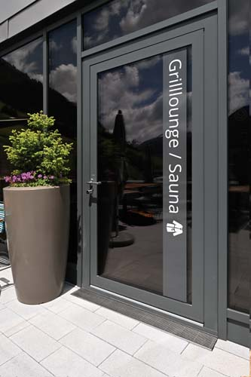 | RichardBrink_Silvretta_12 | Some of the Hydra channels were made to measure to create a perfectly fitting solution for the various door areas, saving a lot of time during installation.  Photo: Richard Brink GmbH & Co. KG
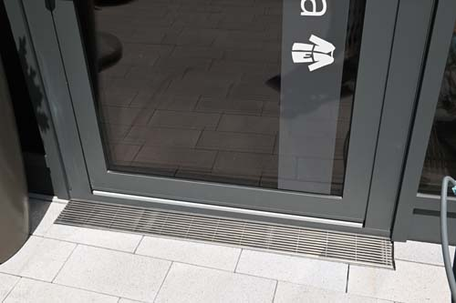 | RichardBrink_Silvretta_13 | The drainage channels are covered by stainless-steel longitudinal bars with a bar thickness of 7 x 7 mm.  Photo: Richard Brink GmbH & Co. KG
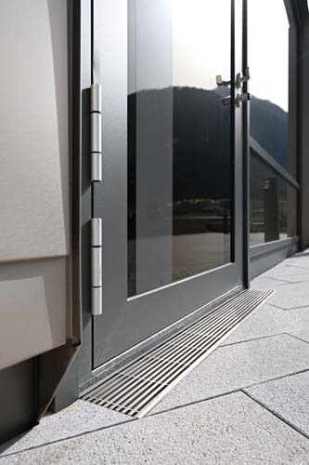 | RichardBrink_Silvretta_14 | The bars slot perfectly into the environment and form an elegant transition between the façade and the paving and can also be walked on barefoot without any problems.  Photo: Richard Brink GmbH & Co. KG
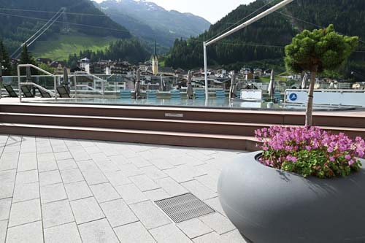 | RichardBrink_Silvretta_15 | A total of 47 additional drainage gullies from Richard Brink were installed in the outdoor area for point drainage.  Photo: Richard Brink GmbH & Co. KG
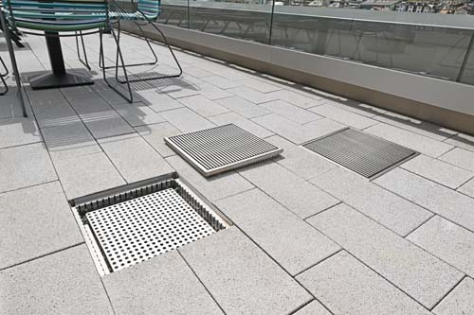 | RichardBrink_Silvretta_16 | Stainless-steel longitudinal bars are also used on the drainage gullies.  Photo: Richard Brink GmbH & Co. KG
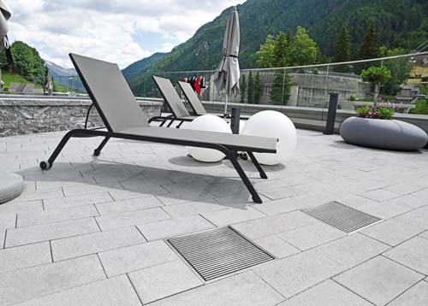 | RichardBrink_Silvretta_17 | The products are manufactured to reflect the slab pattern of the terrace areas exactly to ensure a uniform overall look.  Photo: Richard Brink GmbH & Co. KG

