Image | File name | Caption
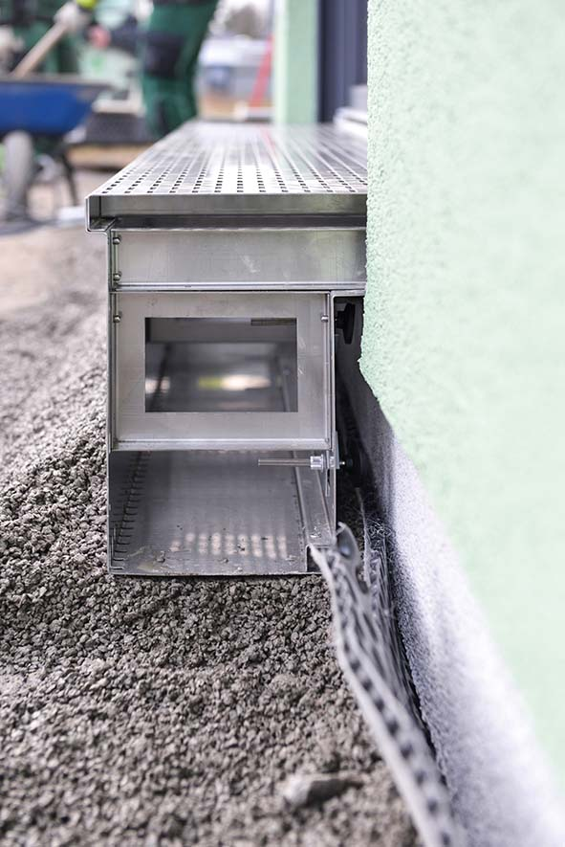 | RichardBrink_StabileAir_Friedrichsdorf_01 | “Stabile Air” façade channels from Richard Brink guarantee drainage of the façade along the base area of a semi-detached house in the Gütersloh suburb of Friedrichsdorf.  Photo: Richard Brink GmbH & Co. KG
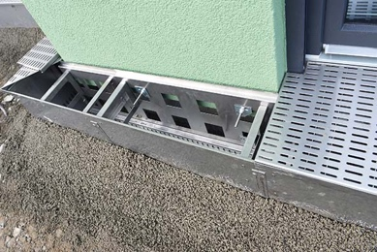 | RichardBrink_StabileAir_Friedrichsdorf_02 | The special channels have large ventilation openings along the façade side to ventilate the base area, making them a suitable choice for wooden and insulated façades.  Photo: Richard Brink GmbH & Co. KG
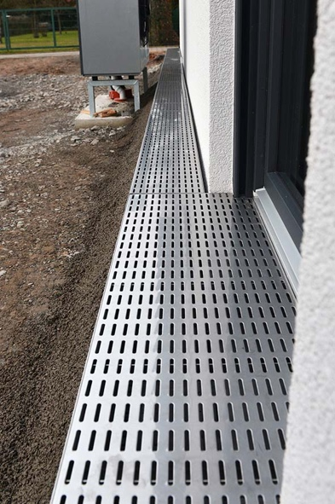 | RichardBrink_StabileAir_Friedrichsdorf_03 | The metal products manufacturer produced most of the channels to the customer’s specific dimensions. Special variants with projecting elements were produced for the reveal areas.  Photo: Richard Brink GmbH & Co. KG
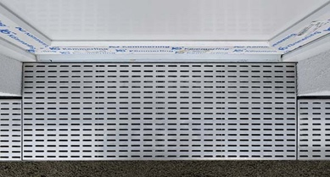 | RichardBrink_StabileAir_Friedrichsdorf_04 | The gratings, also always custom made, guarantee a seamless cover at all times, including in the reveal areas.  Photo: Richard Brink GmbH & Co. KG

