Image | File name | Caption
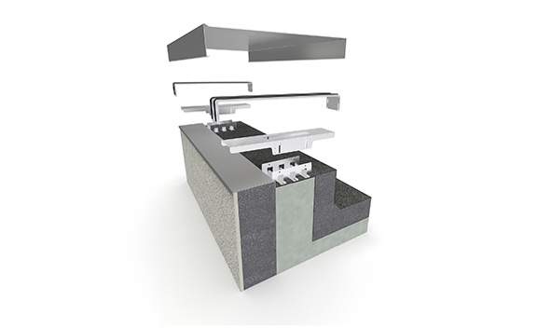 | RichardBrink_CavorFlex_01 | The company Richard Brink has expanded its range of edge profiles to include the Cavor Flex, a height-adjustable substructure for parapet coverings.  Photo: Richard Brink GmbH & Co. KG
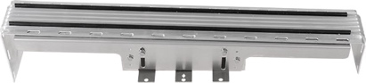 | RichardBrink_CavorFlex_02 | Together with the rubber lip holders, the substructure is installed at specific intervals, wherever two edge profiles join together. The Cavor Flex edge profile system is therefore a mount and connector in one and is an advancement of the time-proven rubber lip holder.  Photo: Richard Brink GmbH & Co. KG
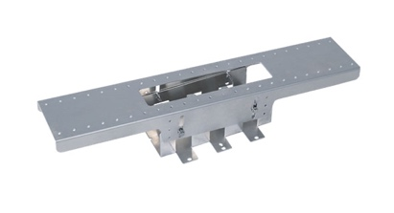 | RichardBrink_CavorFlex_03 | The product’s height is adjusted using the screw connections in the four slotted holes. By setting these at different heights, the two interdependent U-profiles can create a slope in the direction of the roof.  Photo: Richard Brink GmbH & Co. KG
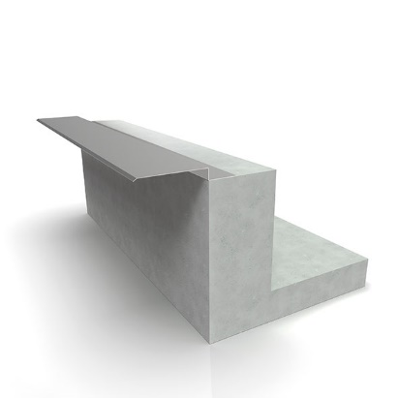 | RichardBrink_CavorFlex_04 | Cavor Flex is screwed to the roof edge either directly or using an optional rebate profile that protects the roof edge against the weather and is fixed to the parapet as a first step.  Photo: Richard Brink GmbH & Co. KG
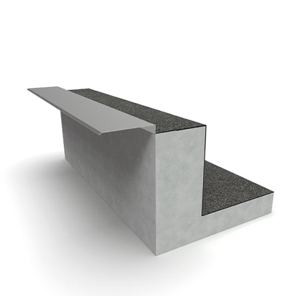 | RichardBrink_CavorFlex_05 | If the profile is attached to the masonry, this creates a preliminary moisture-protection layer for the building structure in the next step together with the first sealing sheet.  Photo: Richard Brink GmbH & Co. KG
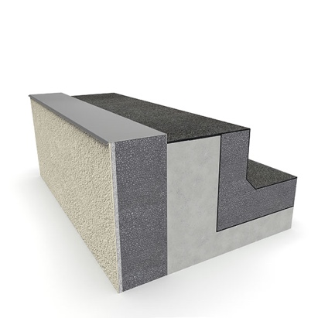 | RichardBrink_CavorFlex_06 | The necessary insulation elements can then be added both on the façade side and in the roof area. As already implied by its name, the weatherproofing rebate profile serves here as a protective and also decorative metal sheet.  Photo: Richard Brink GmbH & Co. KG
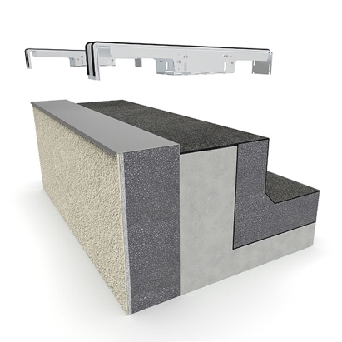 | RichardBrink_CavorFlex_07 | Next, the substructure is directly screwed to the parapet together with the aluminium rubber lip holders.  Photo: Richard Brink GmbH & Co. KG
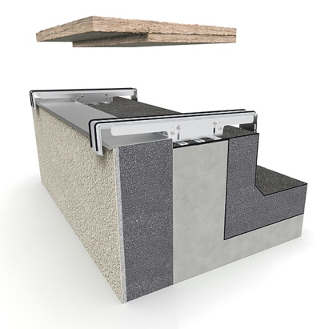 | RichardBrink_CavorFlex_08 | After achieving the necessary gradient with the aid of the substructure, the open spaces between the substructures can be easily insulated.  Photo: Richard Brink GmbH & Co. KG
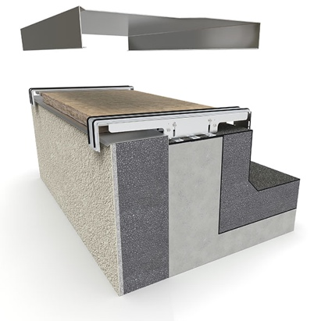 | RichardBrink_CavorFlex_09 | To finish, the custom-made Cavor edge profiles from Richard Brink are positioned over the prepared roof edge and clicked onto the rubber lip holder.  Photo: Richard Brink GmbH & Co. KG
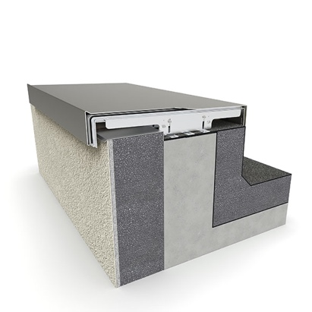 | RichardBrink_CavorFlex_10 | Any accumulating precipitation is directed towards the roof’s dewatering solution by the interlocking complete system provided by Richard Brink, keeping the parapet and façade protected.  Photo: Richard Brink GmbH & Co. KG

