Image | File name | Caption
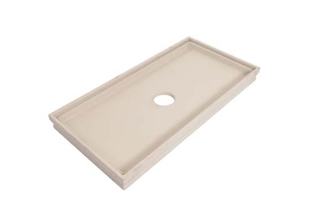 | RichardBrink_CaptusBeton_01 | The company Richard Brink has expanded its assortment of Captus dirt trays to include concrete models as an alternative to the established products made from hot-dip galvanised steel and stainless steel.  Photo: Richard Brink GmbH & Co. KG
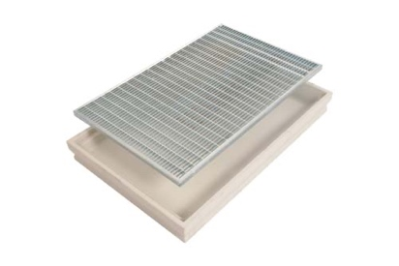 | RichardBrink_CaptusBeton_02 | The concrete versions can be fitted with the same extensive range of gratings already available for the steel dirt trays. While the steel products are always made to measure, the new concrete model is available exclusively in a number of standard dimensions.  Photo: Richard Brink GmbH & Co. KG
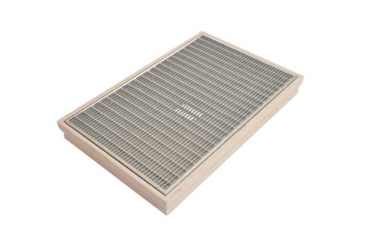 | RichardBrink_CaptusBeton_03 | A hole in DN 100 is cut into the centre of the concrete trays during production. The trays can, however, also be provided with a solid base.  Photo: Richard Brink GmbH & Co. KG
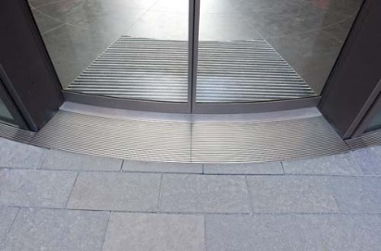 | RichardBrink_CaptusBeton_04 | As well as boot scrapers, the dirt trays can also be fitted with entrance mats.  The steel models allow unlimited design freedom and can even be produced in curved designs.  Photo: Richard Brink GmbH & Co. KG

