Image | File name | Caption
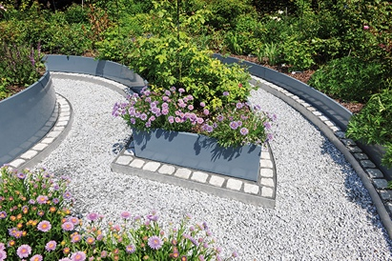 | RichardBrink_Beetumrandungen_01 | Richard Brink GmbH & Co. KG offers a versatile and high-quality range of edging and border solutions that can be used for all kinds of purposes in outdoor spaces.  Photo: Richard Brink GmbH & Co. KG
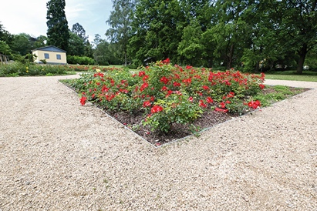 | RichardBrink_Beetumrandungen_02 | For public areas in particular, the Eastern Westphalia metal products manufacturer provides the Ora Max strips, which are made from thick steel and can be supplied as straight edging strips or as custom, pre-shaped curved products.  Photo: Richard Brink GmbH & Co. KG
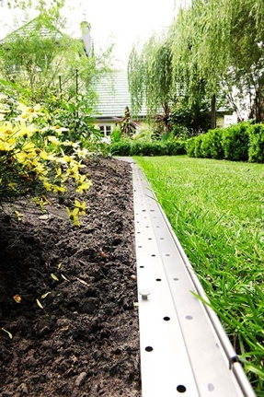 | RichardBrink_Beetumrandungen_03 | The Ora flowerbed edging solution generally satisfies all the requirements of private projects. Thanks to its standard dimensions as well as the option to make the solution to order, spaces of all shapes and sizes can be bordered with precision.  Photo: Richard Brink GmbH & Co. KG
 | RichardBrink_Beetumrandungen_04 | Triangular gaps in the supporting base add a degree of flexibility to the solutions, enabling the creation of curved edges. A range of connectors and earth pins are available to fix the production place depending on the selected model.  Photo: Richard Brink GmbH & Co. KG
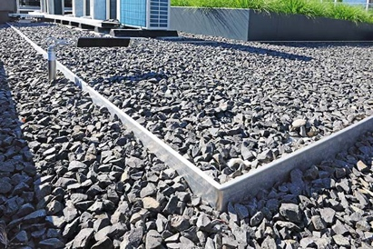 | RichardBrink_Beetumrandungen_05 | Also featuring an L-shaped design, the substrate rails with a backward bend are well suited to delineating two-sided fills.  Photo: Richard Brink GmbH & Co. KG
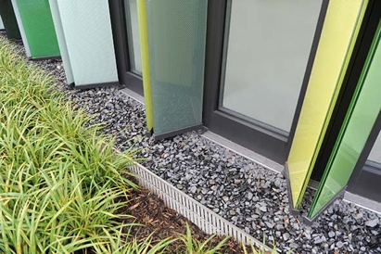 | RichardBrink_Beetumrandungen_06 | If a loose fill is to be used on just one side, customers can choose from the Silex gravel stops with an adjustable height and the Silex Fix with a set installation height.  Photo: Richard Brink GmbH & Co. KG
 | RichardBrink_Beetumrandungen_07 | Both the gravel stops and the substrate rails work well as an edging solution for green roofs.  Photo: Richard Brink GmbH & Co. KG
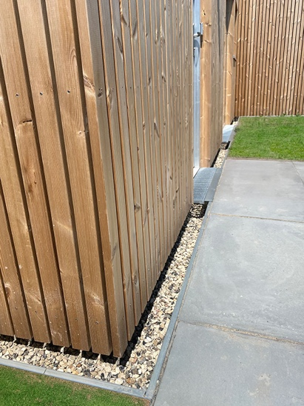 | RichardBrink_Beetumrandungen_08 | What’s more, the manufacturer has recently introduced the Silex Max separation profiles, which protect the façade base from moisture and act as a splash guard while also increasing aesthetic appeal. The profiles can additionally be fitted with step grids in entrance areas.  Photo: Richard Brink GmbH & Co. KG

