Image | File name | Caption
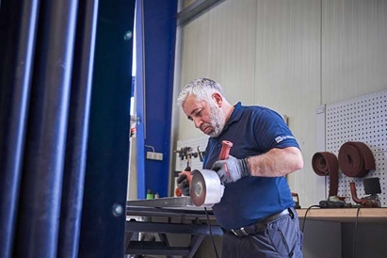 | RichardBrink_niroblech_01 | By taking a stake in the metal processing company, Richard Brink is expanding both its manufacturing and product portfolio.  Photo: niroblech GmbH & Co. KG
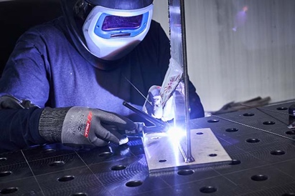 | RichardBrink_niroblech_02 | The expert in custom stainless-steel processing handles a wide range of customer orders, from the manufacture of individual pieces through to large production runs.  Photo: niroblech GmbH & Co. KG
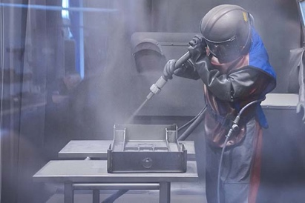 | RichardBrink_niroblech_03 | The broad product range of niroblech GmbH & Co. KG includes activities such as stainless-steel shot-blasting by experienced expert staff.  Photo: niroblech GmbH & Co. KG
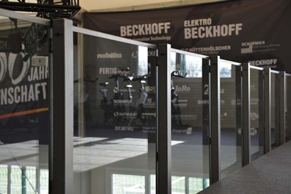 | RichardBrink_niroblech_04 | Similarly, the product portfolio will be expanded upon acquisition of the stake: new additions will include custom-made glass balustrades combined with stainless-steel posts.  Photo: Richard Brink GmbH & Co. KG
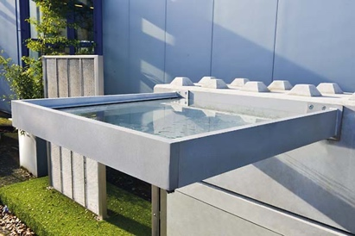 | RichardBrink_niroblech_05 | Additionally, the metal products manufacturer will offer canopies with aluminium frames and glass panes made from laminated safety glass.  Photo: Richard Brink GmbH & Co. KG

