Image | File name | Caption
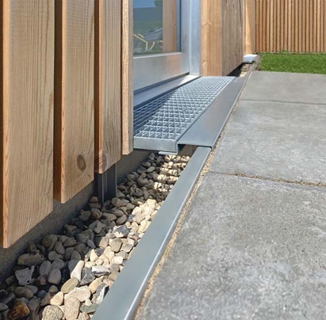 | RichardBrink_SilexMax_01 | Richard Brink has expanded its range of façade drainage products to include the Silex Max separation profile, available in both stainless steel and hot-dip galvanised steel.  Photo: Richard Brink GmbH & Co. KG
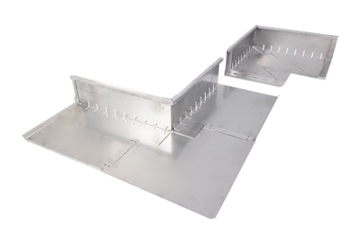 | RichardBrink_SilexMax_02 | By using longitudinal and corner connectors to create inner and outer corners as required, an eaves strip can be laid around the entire house with millimetre precision, keeping the façade well protected.  Photo: Richard Brink GmbH & Co. KG
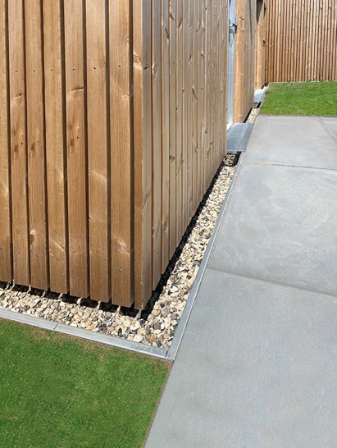 | RichardBrink_SilexMax_03 | The addition of a stone fill protects the base area from moisture damage and acts as a splash guard while also enhancing the overall look of the façade.  Photo: Richard Brink GmbH & Co. KG
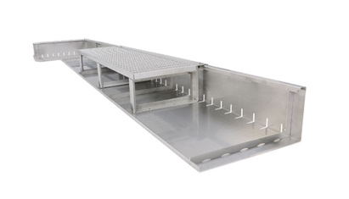 | RichardBrink_SilexMax_04 | Thanks to the integrated drainage slots, accumulating water can be released into the surrounding area, for instance lawns or flowerbeds in the garden.  Photo: Richard Brink GmbH & Co. KG
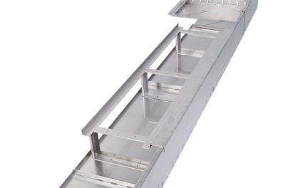 | RichardBrink_SilexMax_05 | Optional grating supports comprising a mounting system and edging frame can be installed in entrance areas to bridge the stone fill and enable a barrier-free transition to the door.  Photo: Richard Brink GmbH & Co. KG
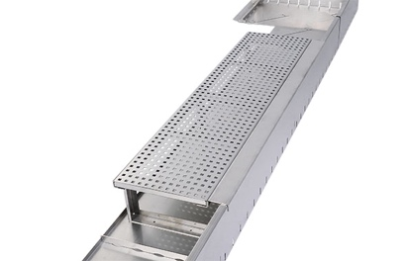 | RichardBrink_SilexMax_06 | The grating supports are available in various designs. The metal products manufacturer produces the supports, as well as all the other elements that make up the separation profile, in various sizes and also custom dimensions on request.  Photo: Richard Brink GmbH & Co. KG

