Image | File name | Caption
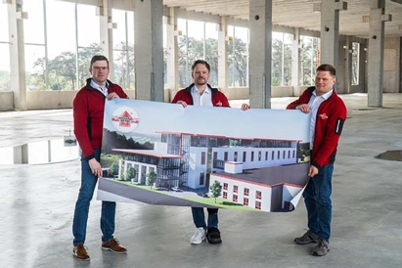 | RichardBrink_Neubau_01 | To keep pace with the growth of the previous years and embrace its plans for the future, Richard Brink is constructing a two-storey new building at its company HQ in Eastern Westphalia.  Photo: Richard Brink GmbH & Co. KG
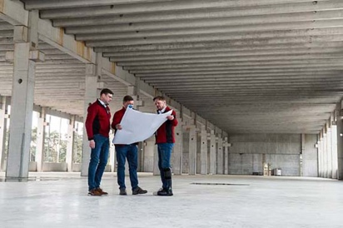 | RichardBrink_Neubau_02 | New manufacturing halls and warehouses with additional office space are emerging, offering total floor space of around 7,000 square metres.  Photo: Richard Brink GmbH & Co. KG
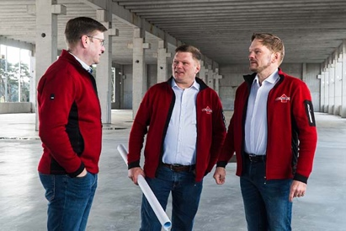 | RichardBrink_Neubau_03 | Established in 1976 as a smithery in a domestic garage, today the mid-sized family company is managed by the second generation. Pictured here are the Managing Directors Stefan, Matthias and Sebastian Brink (left to right).  Photo: Richard Brink GmbH & Co. KG
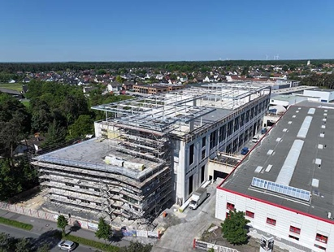 | RichardBrink_Neubau_04 | The aerial photograph of part of Richard Brink GmbH & Co. KG’s company HQ gives a sense of the dimensions of the new building, which will be directly connected to the present warehouse and shipping hall.  Photo: Richard Brink GmbH & Co. KG

