Image | File name | Caption
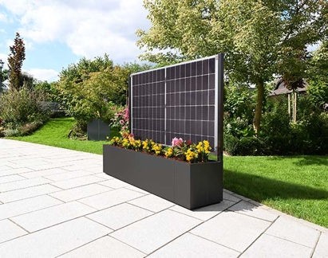 | RichardBrink_ModularSol_01 | Richard Brink has added the Modular Sol plant box to its portfolio of planting systems – the next innovative step in the customisable “Modular” range from the metal products manufacturer.  Photo: Richard Brink GmbH & Co. KG
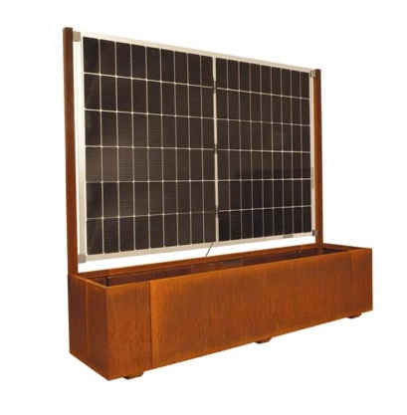 | RichardBrink_ModularSol_02 | The Modular Sol combines the aesthetics of a lush plant box with the benefits of a solar-power unit. The module, which is integrated via clamp mounts, acts as a privacy screen and windbreak at the same time.  Photo: Richard Brink GmbH & Co. KG
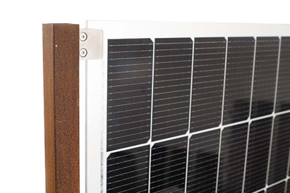 | RichardBrink_ModularSol_03 | A clamp mount attaches the solar panels to the structure via stainless-steel plates. The plant box itself can be made from corten steel or coated aluminium.  Photo: Richard Brink GmbH & Co. KG
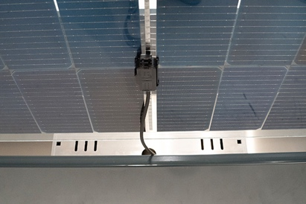 | RichardBrink_ModularSol_04 | Simply plug & play: the complete package, including the pre-installed 400-watt power inverter, is ready for use as soon as it is connected to the power grid.  Photo: Richard Brink GmbH & Co. KG
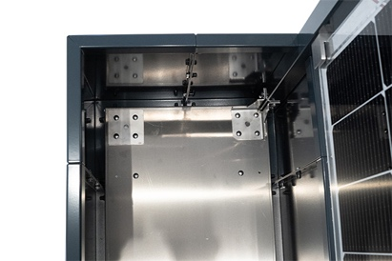 | RichardBrink_ModularSol_05 | The entire structure has been designed to be stable and reliable – from the base through to the fixing element. Additionally, weight produced by the plants ensures that the unit is stably supported.  Photo: Richard Brink GmbH & Co. KG
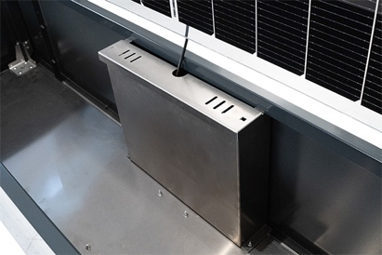 | RichardBrink_ModularSol_06 | Multiple boxes can be easily combined, so they can also be tailored to various customer requirements and uses. The technical box enables multiple Modular Sol units to be connected in series to increase the electricity feed-in.  Photo: Richard Brink GmbH & Co. KG

