Image | File name | Caption
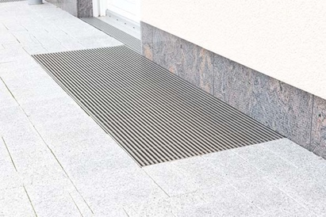 | RichardBrink_Lichtschacht_01 | Richard Brink offers its customers custom-made light-shaft covers with a range of grating designs.  Photo: Richard Brink GmbH & Co. KG
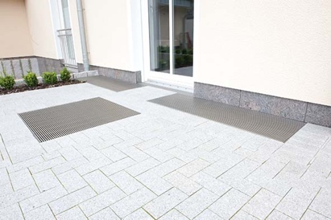 | RichardBrink_Lichtschacht_02 | The product range includes both custom-made gratings for existing angle frames as well as complete packages containing grating and angle frame.  Photo: Richard Brink GmbH & Co. KG
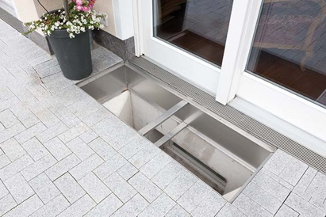 | RichardBrink_Lichtschacht_03 | The stainless-steel frames can be optionally reinforced on the wall side or fully lined. In terms of fixing, the metal products manufacturer offers variants that can be screwed down or set in concrete.  Photo: Richard Brink GmbH & Co. KG
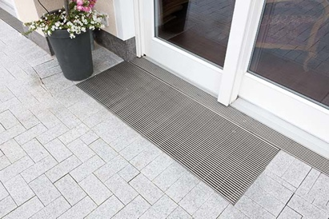 | RichardBrink_Lichtschacht_04 | Customers can choose from an extensive range of gratings for the custom-made covers, extending from a classic mesh grating through to eye-catching design solutions.  Photo: Richard Brink GmbH & Co. KG
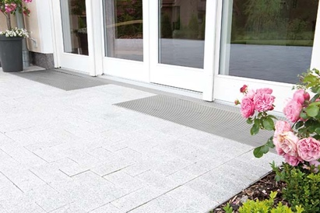 | RichardBrink_Lichtschacht_05 | Richard Brink provides a perfect fit for any project, no matter how unique, and achieves results to satisfy the most exacting requirements.  Photo: Richard Brink GmbH & Co. KG

