Image | File name | Caption
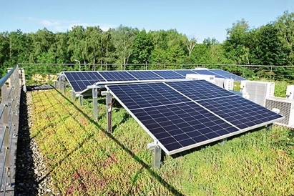 | RichardBrink_SolarGruendach_01 | With the Miralux Green solar substructure, photovoltaic elements can be combined with an extensive green roof.  Photo: Richard Brink GmbH & Co. KG
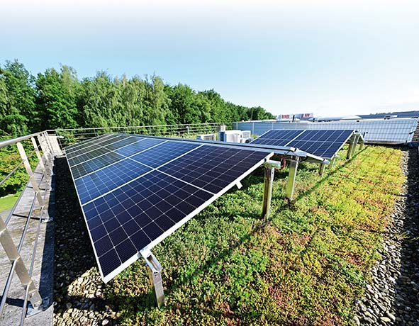 | RichardBrink_SolarGruendach_02 | The green-roof structure on the Richard Brink system simultaneously acts as ballast for the photovoltaic substructure.  Photo: Richard Brink GmbH & Co. KG
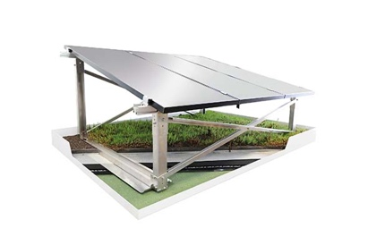 | RichardBrink_SolarGruendach_03 | This is possible thanks to a clever superstructure: a glass fibre mesh placed over support plates for the roof cladding means that the weight of the vegetation is spread across the full area of the substructure.  Photo: Richard Brink GmbH & Co. KG
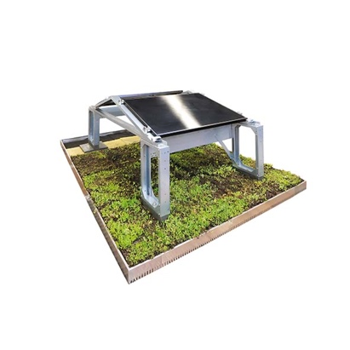 | RichardBrink_SolarGruendach_04 | Richard Brink offers a 60cm-high mounting system suitable both for newbuilds and for retrofitting solar modules on green roofs. The system is screwed to ballast blocks beneath, with the manufacturer’s Miralux Flex substructure fitted on top.  Photo: Richard Brink GmbH & Co. KG

