Image | File name | Caption
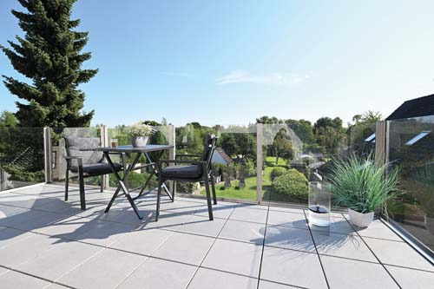 | RichardBrink_Glasgelaender_01 | Richard Brink has added glass systems to its product portfolio, and now also offers products such as tailor-made glass balustrades.  Photo: Richard Brink GmbH & Co. KG
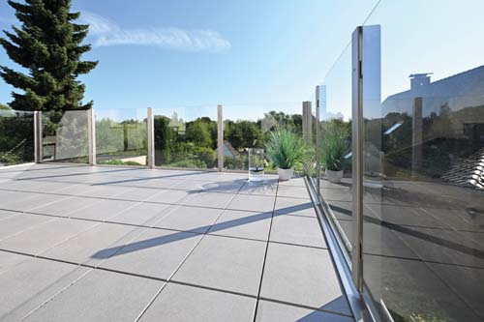 | RichardBrink_Glasgelaender_02 | The system consists of stainless-steel posts with glass supports and retaining plates as well as glass panels made from laminated safety glass.  Photo: Richard Brink GmbH & Co. KG
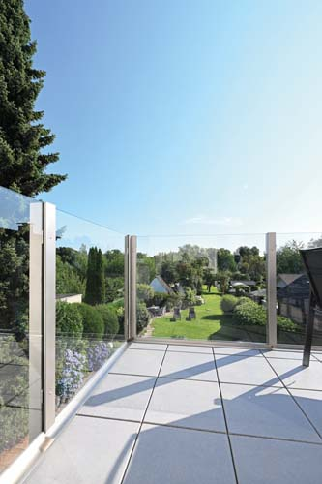 | RichardBrink_Glasgelaender_03 | The maximum distances between the stainless-steel posts are specified based on the chosen height to guarantee the required stability of the balustrades.  Photo: Richard Brink GmbH & Co. KG
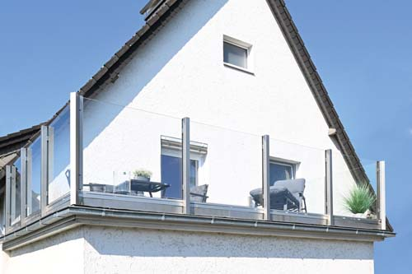 | RichardBrink_Glasgelaender_04 | The balustrades are firmly affixed using retaining plates at the bottom end of the posts.  Photo: Richard Brink GmbH & Co. KG
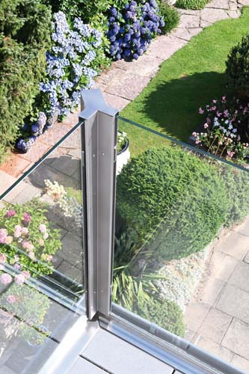 | RichardBrink_Glasgelaender_05 | For the corner connections, the metal products manufacturer provides posts that are able to hold glass panels to either side at a right angle. This maintains the rectangular shape of the balustrade when viewing the solution from the outside.  Photo: Richard Brink GmbH & Co. KG
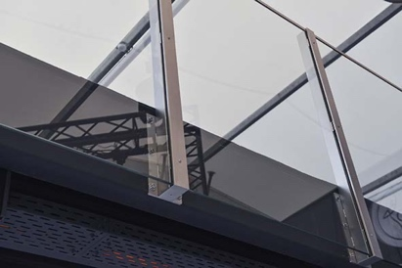 | RichardBrink_Glasgelaender_06 | The maximum projection of the systems is 210mm from the outer edge of the post to the fixing point of the retaining plate.  Photo: Richard Brink GmbH & Co. KG
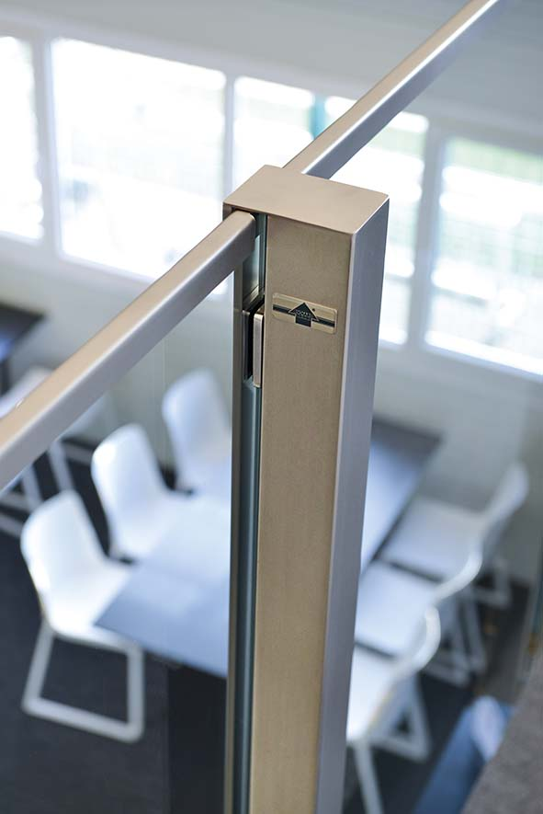 | RichardBrink_Glasgelaender_07 | Both round and square handrails are available in addition to the stainless-steel end profiles depicted here.  Photo: Richard Brink GmbH & Co. KG

