Image | File name | Caption
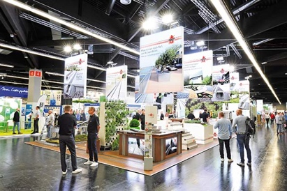 | RichardBrink_Nachbericht_GaLaBau22_01 | Richard Brink exhibited its range of landscape gardening products at the GaLaBau 2022 in Nuremberg.  Photo: Richard Brink GmbH & Co. KG
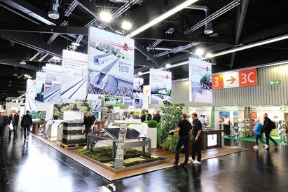 | RichardBrink_Nachbericht_GaLaBau22_02 | It was the metal products manufacturer’s largest trade fair presence so far this year, as reflected in the broad range of products on display.  Photo: Richard Brink GmbH & Co. KG
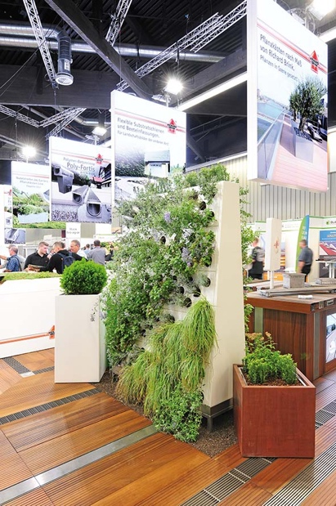 | RichardBrink_Nachbericht_GaLaBau22_03 | The company Richard Brink presented the topic of vertical planting with not one but two versions of its living wall. The Eva model can be seen here, which enables elegant planting in even the tightest of spaces.  Photo: Richard Brink GmbH & Co. KG
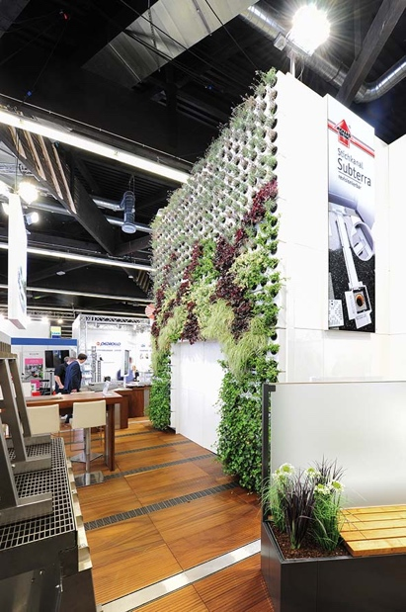 | RichardBrink_Nachbericht_GaLaBau22_04 | With its modular structure, the Adam living wall is the ideal solution for large-scale façade planting. It made for a real visual highlight at the trade fair booth.  Photo: Richard Brink GmbH & Co. KG
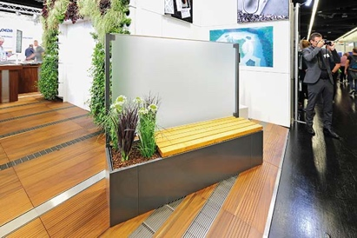 | RichardBrink_Nachbericht_GaLaBau22_05 | The Modular Ventus plant boxes are also new to the range. They incorporate a mix of planting or seating together with a glass privacy screen.  Photo: Richard Brink GmbH & Co. KG
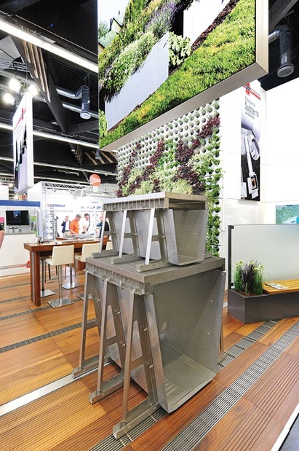 | RichardBrink_Nachbericht_GaLaBau22_06 | Richard Brink GmbH & Co. KG also presented its solutions for efficient rainwater management. Pictured here is the XXL water collection channel FerroMax.  Photo: Richard Brink GmbH & Co. KG
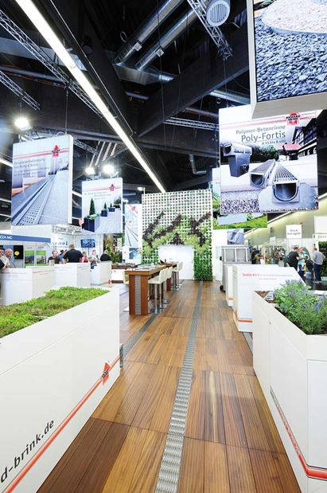 | RichardBrink_Nachbericht_GaLaBau22_07 | The expansive and well-lit exhibition booth provided plenty of space for trade visitors to take in the vast range of products.  Photo: Richard Brink GmbH & Co. KG

